Post-doc and PhD positions in Control and Learning for Exoskeletons and Assistive Devices
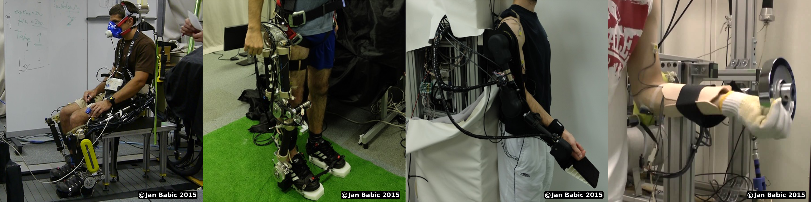
The Department of Automation, Biocybernetics and Robotics at Jozef Stefan Institute in Slovenia invites applications for post-doc researchers and PhD students in the field of control and learning for exoskeletons and assistive robotic devices.
The successful candidates will work on human-robot interfaces, control and learning of exoskeletons for power augmentation, injury prevention and rehabilitation. The research will be focused on models of human motor control and their integration into the control algorithms of robotic systems. The work will be tightly related to several ongoing national and international projects including FP7 and Horizon 2020 projects. Expected starting date is January 2016. Successful candidates will be offered a one-year contract, with possible future extensions.
The candidates should have keen interest in experimental robotic systems and prior experience in robot control and machine learning. The post-doc candidates are required to have PhD in either Computer Science, Electrical Engineering, Mechanical Engineering or a related field. They will be expected to conduct cutting-edge research and publish scholarly papers. The candidates for PhD position should hold either a BSc, MSc or equivalent in either Computer Science, Engineering, Physics or Applied Mathematics. They should have a solid background in linear algebra, statistics, signal processing and programming.
Applications should be emailed to Jan Babic (jan.babic@ijs.si) and should contain a cover letter describing research interests and goals, CV, a complete list of publications, and names and contact information of two references willing to provide letters of recommendation.
--
Dr. Jan Babic | http://www.ijs.si/~jbabic
Dept. of Automation, Biocybernetics and Robotics | http://abr.ijs.si
Jozef Stefan Institute | http://www.ijs.si
Slovenia | http://www.slovenia.si

